Iteration 1 Plan and Backlogs

Team Number: 11

Team Member Names: Chia-Hua Chang; Bin Hu; Zhiqun, Xie;

Team Name: Group 11

Date: 29 May 2024

## Iteration 1 Plan

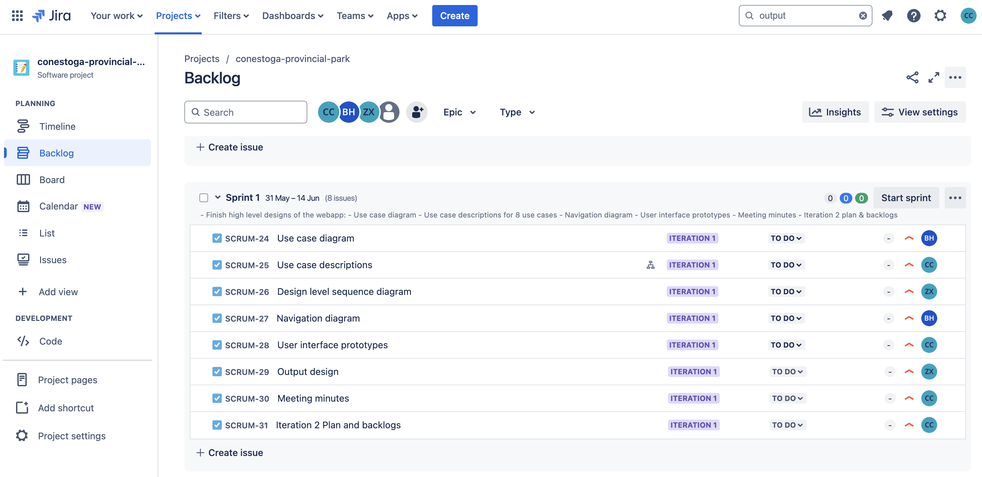

## Sprint 1 Goal

